East Feliciana Parish Planning and Zoning Commission
Joshua O’Quin 5/29
Chairman

Debbie Odom 11/30
Vice-Chairman

Vacant 9/27

Shirley Anderson 10/29

Andy Bishop 3/29

Beau Cotten 9/27

Ashley Ferguson 10/29

Martin Macdiarmid 8/26

Matthew Peterson. 8/26
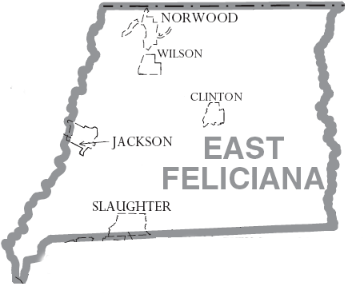
12064 Marston Street
Clinton, LA. 70722
225-683-8577

REGULAR MEETING
AGENDA-Tuesday, 26 May 2026
6:00 p.m. Police Jury Office

1. Call to Order

2. Prayer & Pledge

3. Roll Call7

4. Approve Agenda

5. Approve the 28 April Regular Meeting Minutes.

6. Old Business:

a. Review SLC, LLC map resubmission showing the subdivision of Tract 1-B into Tracts 1-B-1, 1-B-17, 1-B-18, 1-b-19 & 1-B-20(being a portion of the SLC TEC II LLC Et. AL Property) located in Section 42, T4S-R1E, East G.L.D., East Feliciana Parish, Louisiana, Jeff Moody, Surveyor.

b. Review Meares Properties, LLC. map showing survey & division of Tract “D-6-A” into D-6-A-1, D-6-A-2 & D-6-A-3 located in Section 57, T4S-R1E, East G.L.D., East Feliciana Parish, Louisiana, L&L Land Surveying, Inc. Surveyor. (Required signatures from owner giving permission to access servitude)

c. Review and set a public hearing for the revision of Appendix A. Subdivision Ordinance.

7. New Business: All maps have been advertised by R.S. 33-113.

a. Maps advertised & requiring Public Hearings:

1) John and Irene Gonzales map showing survey and division of Tract 4-H-A of The Former Eldred Gross Farm into Tracts 4-H-A-1, 4-H-A-2, 4-H-A-3, and 4-H-A-4 Located in Sections 68, T3S-R2E, East G.L.D East Feliciana Parish, Louisiana. Bradley Roberts, Surveyor

2) Jeffery Devall map showing the division of Tract A-1 into Tracts A-1-4 and A-1-B Located in Sections 65, 66 & 75 & 79, T2S-R2E, East G.L.D East Feliciana Parish, Louisiana. Legacy Surveying & Mapping, LLC., Surveyor

3) Joel A. Martin & Brandi L. Martin map showing subdivision of Lot 8 of Oakwood Subdivision into Lots 8-A & 8-B Located in Section 46, T2S-R2E, East G.L.D East Feliciana Parish, Louisiana. Shane J. Nicholas, Surveyor

4) Kerwin Hardy, Jr. map showing the subdivision of Lot “B” (Formerly Sterling Cannon, Sr,) into Lots “B-1”, “B-2”, & “B-3” Located in Sections 108, T3S-R1W, East G.L.D East Feliciana Parish, Louisiana. Charles Romaine, Surveyor

5) J & Moody Investments, LLC (Owner Lot 1) and Nicky & Samantha Mancuso (Owner Lot G)map showing the removal of a 0.050 acre triangular parcel from Lot 1 (3.31 acres) leaving Lot 1-A (3.26 acres) and the subsequent consolidation of said parcel with adjoining Lot G (1.00 acre) to form Lot G-1 (1.05 acres) Located in Section 40, T4S-R2E, G.L.D East Feliciana Parish, Louisiana. Jeff Moody, Surveyor

6) Cynthia “Cindy” Gail Courtney McDonald (Owner/Client) & Shawn Sagrera (Client) (Cindy McDonald Owner of Lot A (2.00 acres) & Called 2.5 acres Lot) map showing the subdivision of Lot A (2.00 acres) and A called 2.5 acres Lot into Lot A-1 (2.50 acres) Lot X (2.00 acres) as shown heron Located in Sections 71, T3S-R3E, East G.L.D East Feliciana Parish, Louisiana. Jeff Moody, Surveyor

b. Maps considered under Administrative Procedures & Exceptions:

1) Randall L. Taylor & Brittany Leigh Taylor map showing an exchange of property between Lots D-1 & D-2 of The W. Flynn Needham Tract into Lots D-1-A & D-2-A Located in Sections 34, T2S-R1E, East G.L.D East Feliciana Parish, Louisiana. Shane J. Nicholas, Surveyor

c. Other:

8. Police Jury.

9. Legal Advisor.

10. Public Comment: Note: Public Comment: Three (3) minute limit per individual.

11. Adjourn

Josh O’Quinn,
Chairman

