East Feliciana Parish Planning and Zoning Commission
Joshua O’Quin 5/29
Chairman

Debbie Odom 11/30
Vice-Chairman

John Rouchon 9/27
Secretary

Shirley Anderson 10/29

Andy Bishop 3/29

Beau Cotten 9/27

Ashley Ferguson 10/29

Martin Macdiarmid 8/26

Matthew Peterson. 8/26
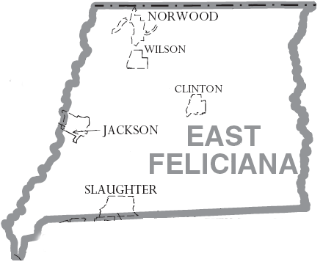
12064 Marston Street
Clinton, LA. 70722
225-683-8577

REGULAR MEETING
AGENDA-Tuesday, 27 January 2026
6:00 p.m. Police Jury Office

1. Call to Order

2. Prayer & Pledge

3. Roll Call

4. Approve Agenda

5. Approve the 25 November Regular Meeting Minutes.

6. Old Business: None.

7. New Business: All maps have been advertised as per R.S. 33-113.

a. Maps advertised & requiring Public Hearings:

1) Richard Carlson, Sr. & Cherree Carlson map showing division of Lots 4-A, 5-A & Glencoe Trace into Lots 4-A-1 & 6-A located in Section 65, T2S-R1E, East G.L.D., East Feliciana Parish, Louisiana, McLin Taylor Engineering & Land Surveying, LLC, Surveyor.

2) J Moody Investments, LLC map showing the resubdivision of Lots J-1, J-2 & J-3 Formerly A Part of The Lester Ray Schmidt Tract into Lots 1 thru 5 located in Sections 8 & 40, T4S-R2E, East G.L.D., East Feliciana Parish, Louisiana, Jeff Moody, Surveyor.

3) Justin & Maranda Williams (Owner of Tract F-1), Cameron & Brandy Wheeler (Owner Tract F-2) and Clarence & Teresa Huegler (Owner Tract D-1-A-1) map showing the subdivision of Lot A-2 owned by Fay Neyland Leteeff into Lots A-2-A (3.54 AC), A-2-B (3.03 AC) & A-2-C (8.16 AC) and the subsequent consolidation of said Lots A-2-B & A-2-C with adjoining Tracts F-2 & D-1-A-1 to form Tracts F-2-A-2-B (7.78 Acres) & D-1-A-1-A-2-C (14.39 acres) located in Section 70, T3S-R3E, East G.L.D., East Feliciana Parish, Louisiana, Jeff Moody, Surveyor.

4) M&J Civil Construction, LLC map showing the subdivision of Lots 6, 7 & 8 called 10.5 acres each but found to contain a total of 33.04 acres into Tracts X (20.52 acres), Y (6.85 acres) & Z (5.67 acres) located in Section 65, T3S-R1E, East G.L.D., East Feliciana Parish, Louisiana, Jeff Moody, Surveyor.

5) Ethel Wingfield map showing division of property of Lot F Eddie Adams, Sr. Property into Lots F-1, F-2, & F-3 located in Section 46, T2S-R1E, East G.L.D., East Feliciana Parish, Louisiana, L&L Land Surveying LLC, Surveyor.

b. Maps considered under Administrative Procedures & Exceptions:

1) Ethel Wingfield & David and Roselyn Deloach map showing exchange of property Lots A-1-A & A-1-D of The Ethel Lee Adams Wingfield Property Lots A-1-A-1 & A-1-D-1 located in Section 46, T2S-R1E, East G.L.D., East Feliciana Parish, Louisiana, L&L Land Surveying LLC, Surveyor.

2) Jess Hughland Easely, Sr. map showing an exchange of property between Tract A & Tract B of The Previous Hall Estate into Tract A-1 & Tract B-1 located in Section 78, T3S-R2E, East G.L.D., East Feliciana Parish, Louisiana, Shane Nicholas, Surveyor.

c. Other: Approve 2026 Meeting Dates.

8. Police Jury.

9. Legal Advisor.

10. Public Comment: Note: Public Comment: Three (3) minute limit per individual.

11. Adjournment
JR
JOHN ROUCHON, Secretary

